

**Data Analytics using Python**

**REPORT**

**ON**

**Sentiment Analysis and Comparative Insights on Product Reviews(WHEY PROTEIN)**

**Table of Contents**

**1. Executive Summary (1)**

**2.Introduction (1)**

**3. Methodology (1)**

* **Data Preparation (1)**
* **Sentiment Analysis (1)**
* **Visualization (1)**
* **Comparative Insights (1)**

**4. Findings and Insights (2)**

* **Key Insights from Sentiment Analysis (2)**
* **Comparative Analysis (2)**

**5. Recommendations (2)**

* **Product Improvements (2)**
* **Marketing Strategies (2)**
* **Customer Engagement (3)**

**6. Conclusion (3)**

**7. Supplementary Information (3)**

* **R Code (3-4)**
* **Bar Graph (4-7)**
* **Data Source**

**8. Drillbit Report (8)**

**Executive Summary**

This report analyzes customer feedback for five protein supplement brands: MuscleBlaze, Avvatar, Optimum Nutrition, Big Muscles, and MuscleTech. Sentiment analysis was used to identify key trends, patterns, and actionable insights to enhance product offerings and customer engagement strategies. Visualizations and comparative analyses highlight strengths and areas for improvement for each brand.

**Introduction**

This analysis evaluates customer reviews to understand sentiment distribution and identify opportunities for product improvement and marketing strategies. The data includes structured customer feedback for five protein brands, providing insights into customer satisfaction, strengths, and challenges for each product.

**Methodology**

**Data Preparation**

The datasets were cleaned and processed using text mining tools to remove irrelevant data and prepare the text for analysis. Reviews were segmented by brand for targeted insights.

**Sentiment Analysis**

Sentiment scores were extracted using a sentiment analysis tool that categorized emotions such as joy, trust, anger, and sadness. Each review was also labeled as positive, neutral, or negative.

**Visualization**

Bar charts were generated to visually compare sentiment scores across brands, illustrating emotional distribution and overall sentiment balance.

**Comparative Insights**

The results were compared across the five brands to identify trends and highlight key differences in customer feedback, which were then connected to potential product strengths or weaknesses.

**Findings and Insights**

**Key Insights from Sentiment Analysis**

* **Positive Sentiment:** MuscleTech and Big Muscles lead in positive customer feedback, indicating high satisfaction.
* **Negative Sentiment:** Optimum Nutrition shows higher negative sentiment, suggesting potential issues with product quality or service.
* **Emotional Trends:** Trust and anticipation are consistently high across all brands, reflecting customer optimism.

**Comparative Analysis**

* **MuscleBlaze:** Strong trust sentiment positions it as a reliable brand.
* **Avvatar:** Balanced feedback with notable joy sentiment indicates positive user experience.
* **Optimum Nutrition:** Higher negative sentiment suggests areas for product or service improvement.
* **Big Muscles:** High levels of positive sentiment and trust highlight strong customer satisfaction.
* **MuscleTech:** Exceptional positive sentiment emphasizes its leadership in customer satisfaction.

**Recommendations**

**Product Improvements**

* Optimum Nutrition should address negative sentiment by investigating product-related complaints.
* MuscleBlaze can enhance features to better compete with Big Muscles and MuscleTech.

**Marketing Strategies**

* MuscleTech and Big Muscles should capitalize on their strong positive sentiment in promotional campaigns.
* All brands can use trust and anticipation as themes in marketing to build customer loyalty.

**Customer Engagement**

* Optimum Nutrition should focus on improving customer support to reduce dissatisfaction.
* Brands should continuously monitor sentiment trends to remain responsive to customer needs.

**Conclusion**

This analysis reveals that MuscleTech and Big Muscles outperform competitors in customer satisfaction, while Optimum Nutrition faces challenges requiring immediate attention. Expanding this study to include additional feedback sources could provide a more comprehensive understanding.

**Supplementary Information**

**R Code**

library(NLP)

library(tm)

library(syuzhet)

View(Muscleblaze)

View(AVVATAR)

View(Optimum_nutrition)

View(BIG_MUSCLES)

View(MUSCLE_TECH)

data1=Muscleblaze$content

data2=AVVATAR$content

data3=Optimum_nutrition$content

data4=BIG_MUSCLES$content

data5=MUSCLE_TECH$content

sentiment1=get_nrc_sentiment(data1)

sentiment2=get_nrc_sentiment(data2)

sentiment3=get_nrc_sentiment(data3)

sentiment4=get_nrc_sentiment(data4)

sentiment5=get_nrc_sentiment(data5)

barplot(colSums(sentiment1),las=2,col=rainbow(10),ylab='count',main='MuscleBlaze')

barplot(colSums(sentiment2),las=2,col=rainbow(10),ylab='count',main='Avvatar')

barplot(colSums(sentiment3),las=2,col=rainbow(10),ylab='count',main='Optimum Nutrition')

barplot(colSums(sentiment4),las=2,col=rainbow(10),ylab='count',main='Big Muscles')

barplot(colSums(sentiment5),las=2,col=rainbow(10),ylab='count',main='MuscleTech')

**Bar Graphs**

* **MuscleBlaze**

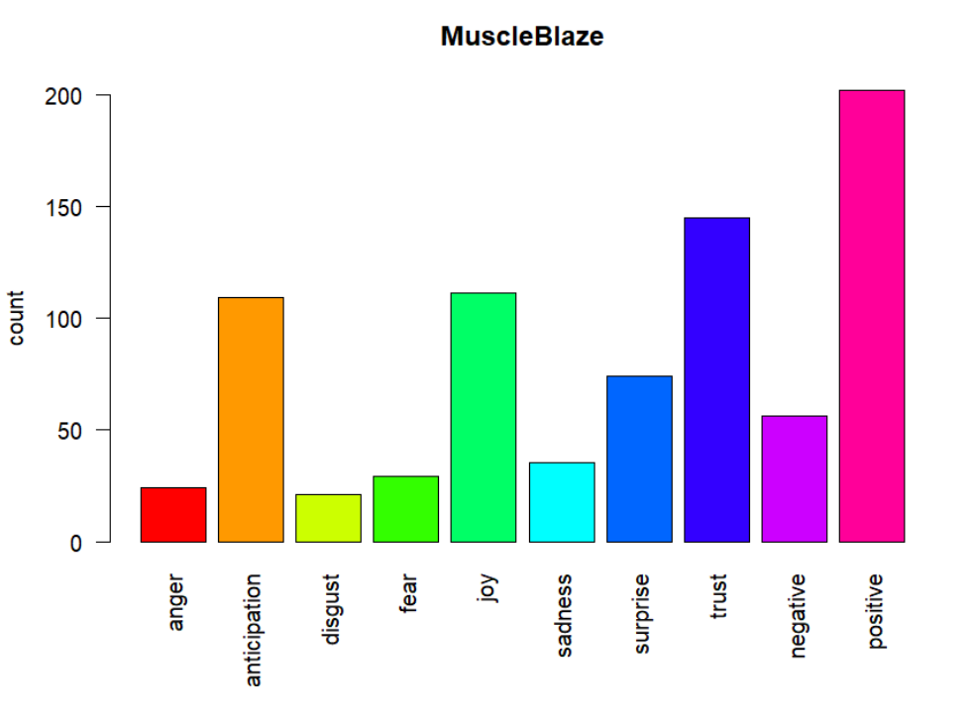

* **Avvatar**

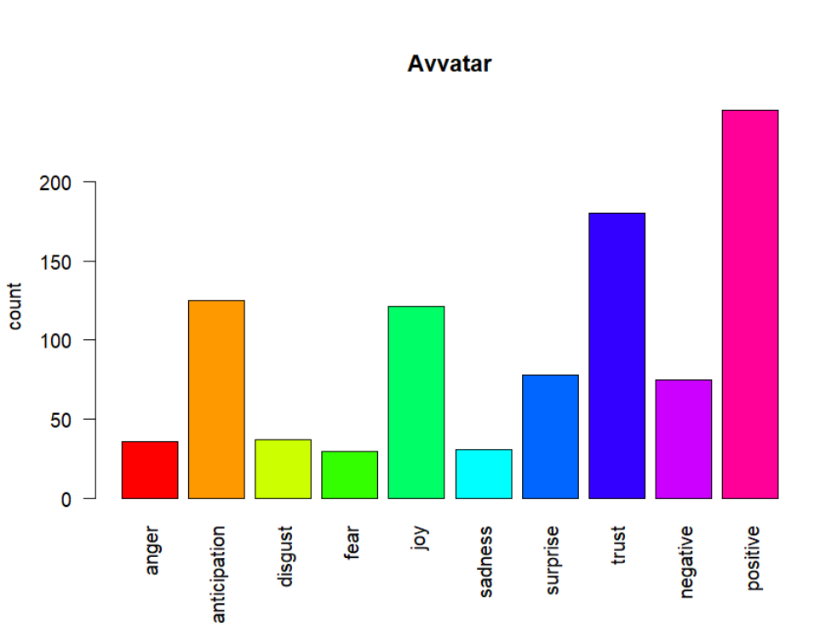

* **Optimum Nutrition**

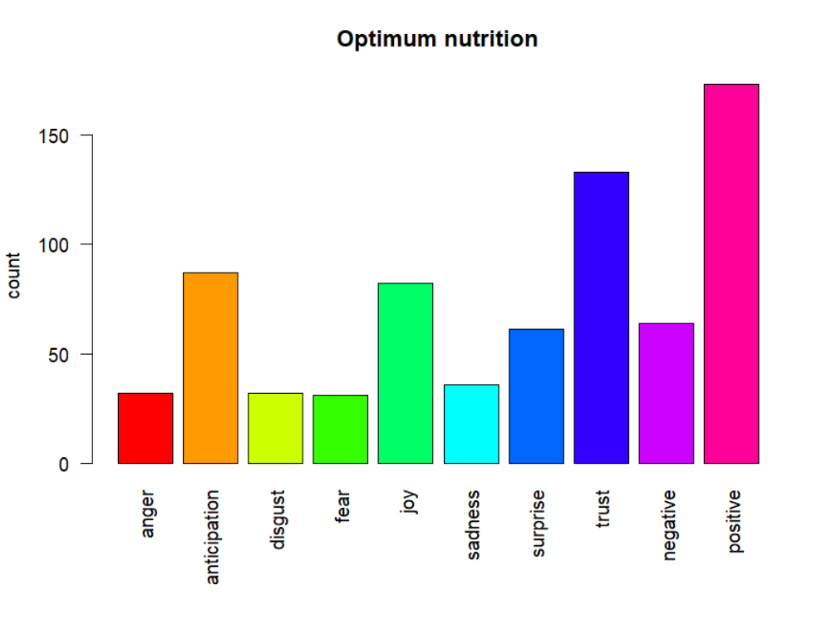

* **Big Muscles**

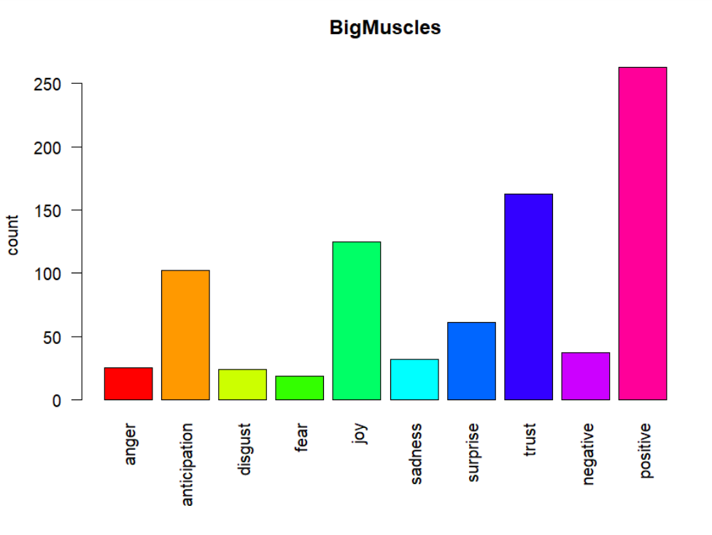

* **MuscleTech**

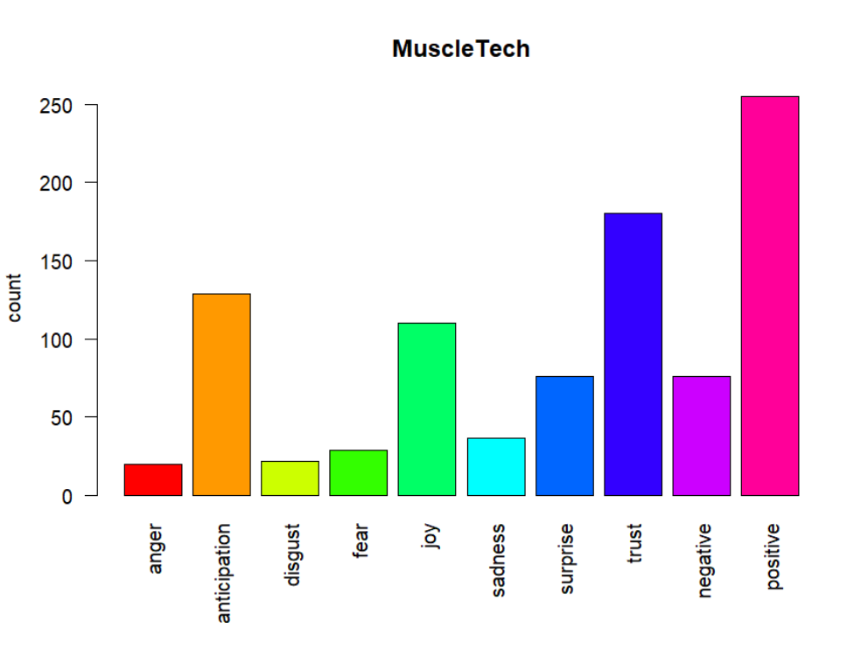

**Data Source**

**Drillbit Report**

